e-PROCUREMENT APPLICATION SYSTEM

# introduction

Procurement requisition is a very important function in any corporate body. An efficient procurement system gives management an idea into the requisition and consumption patterns of assets, be it fixed or current, tangible or intangible, operating or non-operating by various business units.

Armed with this information, management can deduce the financial resources to appropriate towards the purchase of certain services, purchases and contracts.

The PASL electronic Procurement system (aka e-Procurement) is a web-enabled application. It is designed purposely to enable all business units (i.e. branches, departments and units alike) to be active stakeholders in the requisition process. It also aims at shortening the turn-around-time (TAT) for requisitions by seventy percent (70%). TAT is calculated from the time a requisition is ***initiated*** to the time requested service, contract or purchase is ***received*** and ***confirmed***.

The document that follows is a *brief* of the system: it is meant for end users with little or no knowledge of web applications. However, the knowledge of the use of internet browsers (i.e. Firefox, Google Chrome, Internet Explorer and Microsoft Edge) is assumed.

**LOGGING IN**

To log in to the eProcurement Application System, follow the instructions below:

1. Open an internet browser on your machine. The application works ***best*** with Mozilla Firefox, Google Chrome and Microsoft Edge browsers.
2. Type <http://10.150.0.42/Procurement> into the address bar of the browser and press the enter key. Figure 1.1 shows the address bar of a Firefox browser with the address:

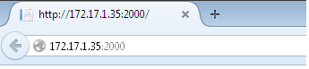

Address bar with address

1. A password challenge page appears. User should enter username and password and click on the Login button. The user credentials is verified by the system. The user is able to access the system **ONLY** when his/her credentials is positively verified. If verification fails, user gets a response that “*Invalid user credentials. Please try again*”

Verification success takes user to a desktop – like screen with various icons depicting actions to perform. The number and type of icons seen by a user is determined by his/her profile setup.

Figure 1.2 shows the password verification process:

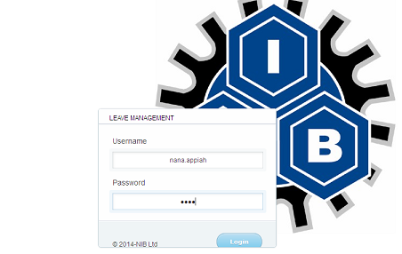

**USER PROFILE FOR DATA ENTRY OFFICER**

Users with data entry profile will have access to the “Requisition” icon as depicted in figure 1.3. This profile is assigned to a user who has been designated by his branch, department, or unit, or made a proxy by his/her unit head. With that access, a user can make requisitions on behalf of his outfit. Figure 1.5 shows the form used in making the requisition request:



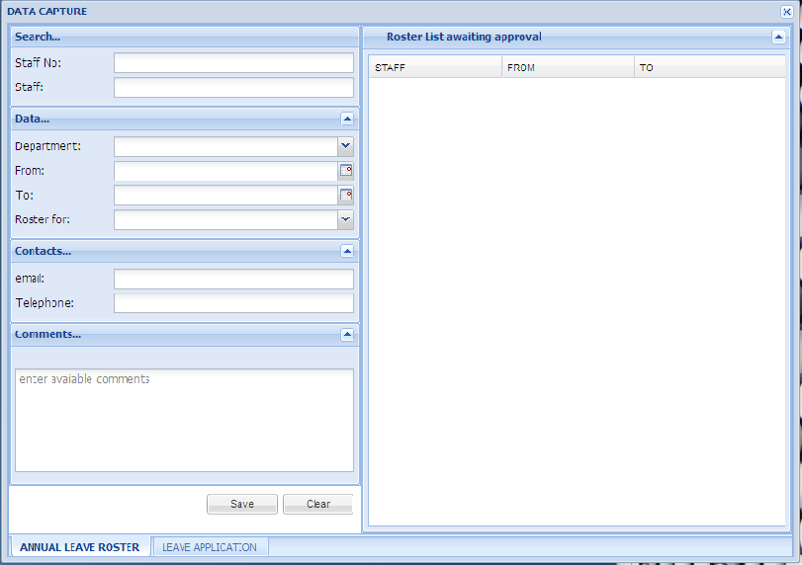

All items registered by the Administrative Officer in the system are displayed. In order to select an item for requisition, the system user has to double-click on an item. A textbox appears, given the user the chance to input the quantity (i.e. units) of the item to requisition.

After making the necessary selections, user should click on the **Add Selected** button. A non-mandatory brief comments can be added to describe the nature of the requisition. Click on the **Send Requisition** button to save the procurement request.

**Note**: All the fields are mandatory with the exception of the *Brief comments* field.

**Financial Approval Form**

This form is ***only seen*** by a user who has been assigned the *Financial Controller profile*. The Financial Controller, or his proxy uses this form to give an *initial approval* to a requisition. In doing so, he is able to check the request against the CAPEX data sent by the requesting unit at the commencement of the year. If requesting item is found in the CAPEX, and Financial Controller determines that the requisition will not adversely affect the bottom line of PASL, ceteris paribus, approval is given.

To approve a requisition:

* Click on the search drop-down list to select a branch
* All requisitions for the branch will be displayed underneath.
* Double-click on a requisition to see the requisition details (requestee, department, priority, etc), and the items being requested.
* Double-click on requested item and select either “Approve” or “Decline” in the status column.
* Click on the **Save** button. When approval is given, the Administrative officer can commence vendor selection and procurement process.

Capex

It is the second tab on the Financial Approval form. The Capex tab shows all the CAPEX data collated from the Branches, Departments or units. User can view CAPEX of distinct units, or click on the **Fetch All** button to view the entire CAPEX submitted.

System also allows for data to be exported (into comma-separated-value format)

Capex Status

The third tab on the form is Capex Status. It is used to determine a specific period, or window of time, for which branches, departments and units can input their CAPEX.

**How to use Capex status**: Finance Department can determine that, branches have from the beginning of a year to the 31st of January to input their CAPEX. When the date in question expires, Finance department can click on **CLICK ON CLOSE CAPEX** to cease the window for accepting CAPEX inputs from branches.

Figure 1.6 shows the financial approval form. **Note:** With the exception of the comments field, all other fields are mandatory.

**PROCUREMENT MANAGEMENT**

The Procurement management form is essentially the engine of the application. It is where requisitions, which have been given prior approval by the Financial Controller, are processed. It is one of many forms that can be accessed **only** by a system user having the ***Administrative officer profile***.

The Form has two (2) tabs: *Build LPO* and *Create LPO*.

Build LPO

* Click on the Search drop-down list to select a department.
* Requisitions for the department, prior approved by the Financial Controller is displayed.
* Double-click on a requisition to load requisition details.
* Administrative officer inputs the amount associated with each item in the request in the amount column of the requisition list.
* Click on **Calculate Total Amount** to compute the total amount for all requisition items under consideration.
* Click on the Select Vendor drop-down list to select a vendor for the procurement.
* Click on the Build LPO button.

Note: The process of determining amounts for requisitions, as well as selection of vendor is referenced in the ***PAN-AFRICAN Procurement Policy – v3***, and is strictly adhered to by Administrative Officer.

Create LPO

* Double-click on an item in the Local Purchase Orders table. Items making up the LPO, as well as the vendor and the total amount is displayed.
* Depending on the total amount involved, Admin officer selects the type of procurement. Other fields such as VAT, Purchase Date, Delivery Date, Payment Terms, Cheque No, Shipping Address and Terms and Conditions are filled.
* Click on the **Send LPO for Approval** button.

Note: The total amount involved in the procurement determines the type of procurement. The type of procurement determines the list of individuals in management to give approval for Procurement purchase request to be valid. The procurement amount threshold and their related approval personnel is found in the ***PAN-AFRICAN Procurement Policy -v3***.

**Procurement Approval**

This form can only be accessed by individuals who have been setup in the system, with procurement approval privileges.

Procurement Approval Steps

* Double-click an LPO record under Procurements table to view LPO details, as well as the list of approvers who have given their prior approval.
* Click the drop-down list and select either “Approve” or “Reject”.
* Enter comments regarding your approval decision, and click on **Approve Procurement** button.